April 18-21: Monday to Thursday
April 26-29: Tuesday to Friday
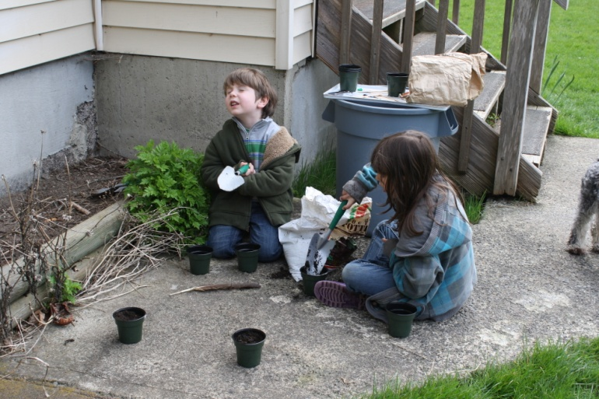
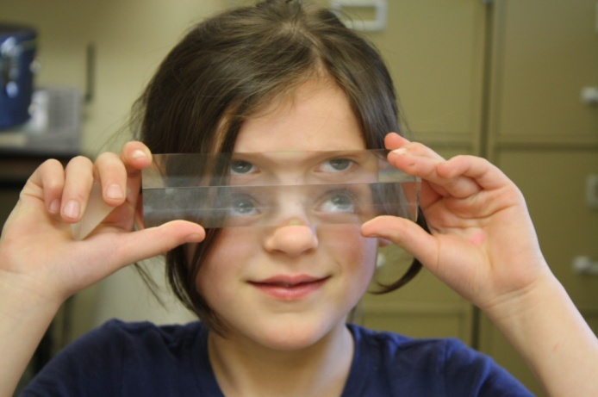
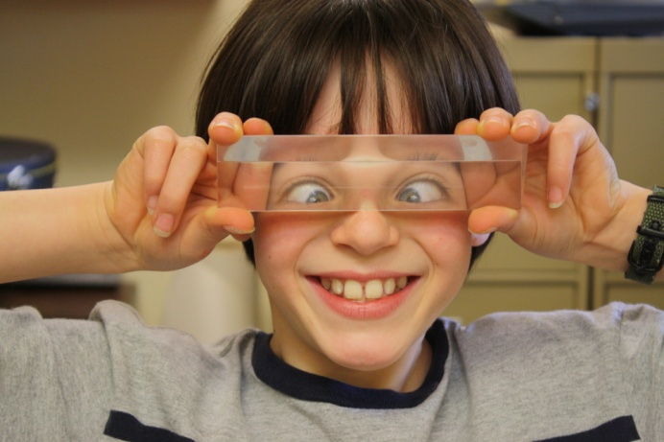
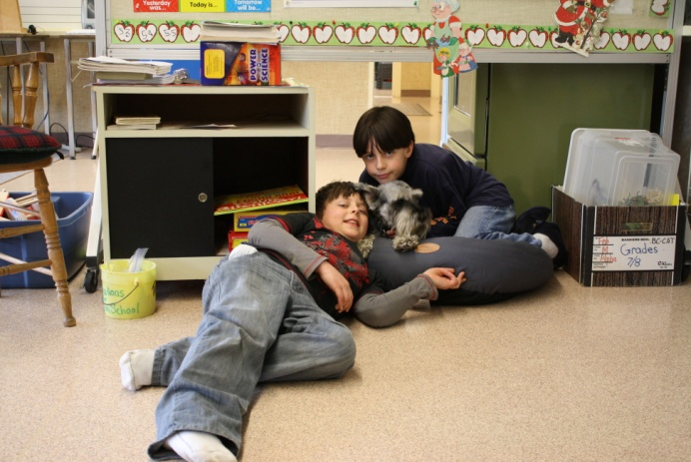
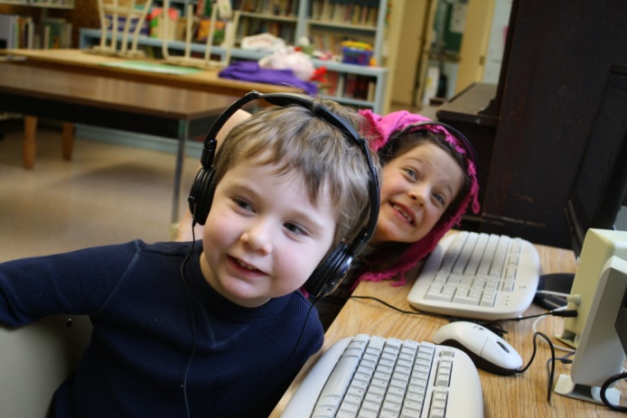

We all had fun planting our seeds this week
Upcoming Events...
April 22nd - Earth Day
April 23rd – Bake Sale
April 25th - Easter Monday
April 29th –Ab-Ed Day on Galiano Island
Please fill out your field trip forms. Brent Sohier will pick up the class on Galiano to bring them home.

